
Habib University
School of Science & Engineering
Student Name/ID
Course: | EE – 211 – Basic Electronics
Semester | Spring 2024
Midterm # | 1
Date, Time, Location : | March 04, 2024, 0830-0950,  H-509
Instructor : | Syed Arsalan Jawed
Total Marks : | 100

Instructions for Students
- Provide your answers within the empty spaces given after each question.
- Keep your answers concise and to the point. Provide neat and tidy calculations and plots.
- Make reasonable assumptions related to concepts and associated parameters motivated by your text and reference book.
- Support your answer with equations where needed.
- You may consult ONLY your class lecture notes during the exam.

Question # 1 : [CLO-1, CLO-2]
For the following circuit, start from the given equation and derive the expressions for diode’s incremental resistance. [20]
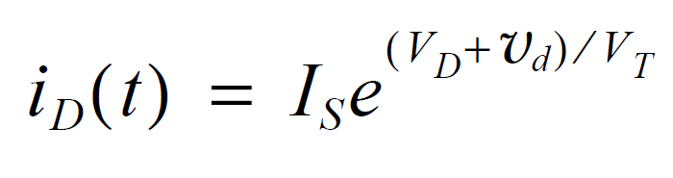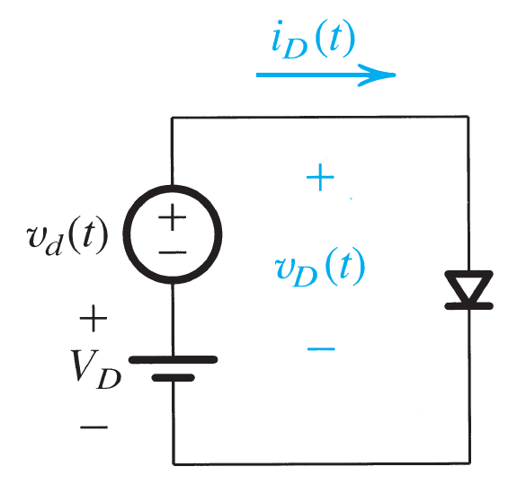

Question # 2 : [CLO-2, CLO-3]
Determine I_{D} and V_{D} for the following circuit using iterative analysis. VDD=5V, R=1 kOhm, VD=0.7V@1mA. [20]
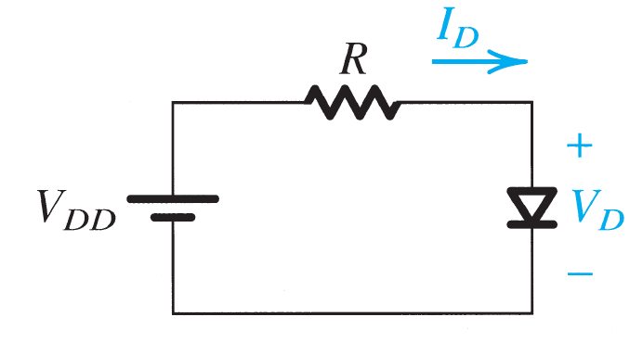

Question # 3 : [CLO-2, CLO3]
Find I and V for the following circuit. [15]
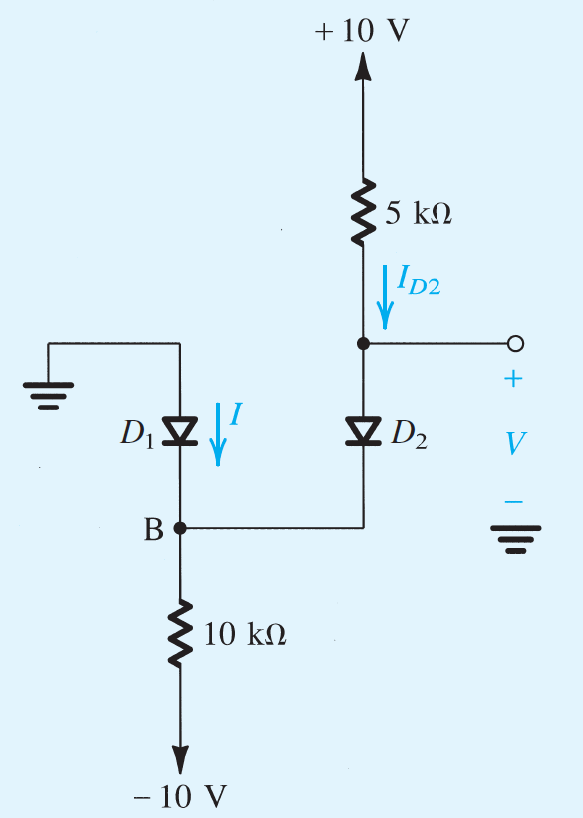

Question # 4 : [CLO-2, CLO-3]
Consider a peak rectifier fed by a 60-Hz sinusoid having a peak value Vp = 100 V. Let the load resistance R = 10 kOhm. Find the value of the capacitance C that will result in a peak-to-peak ripple of 2 V. [15]
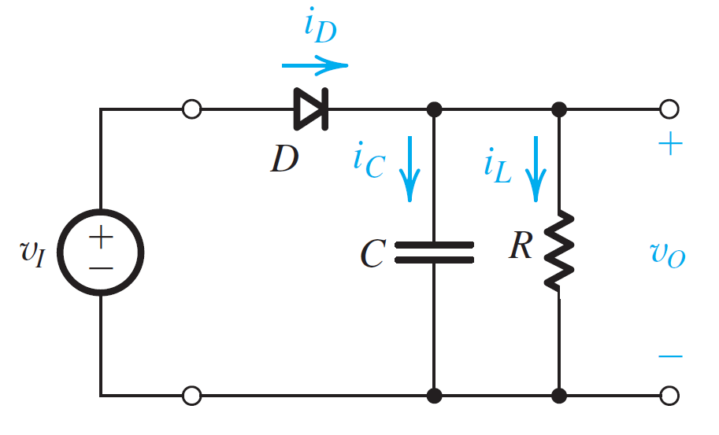

Question # 5 : [CLO-2, CLO-3]
Plot Voltage Transfer Characteristic plots for the following circuits. Assume diodes are ideal. [15]
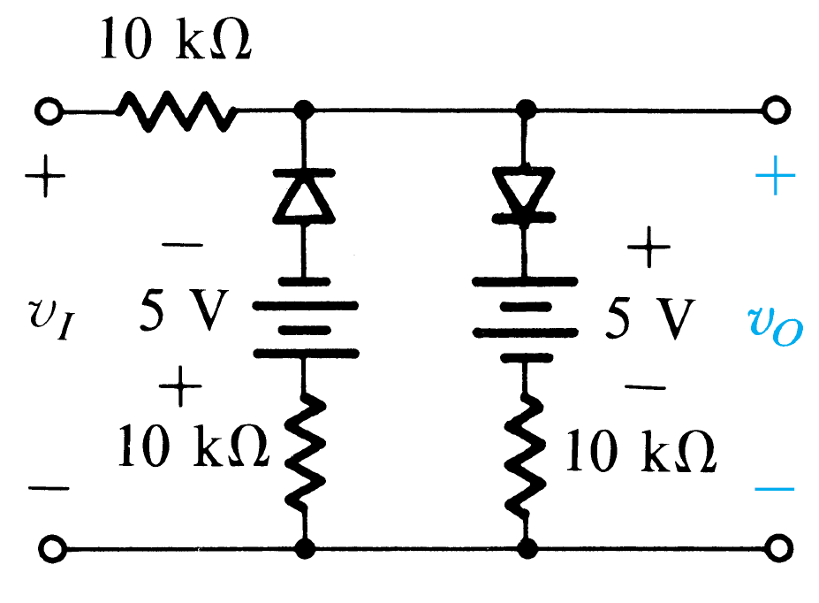

Question # 6 : [CLO-1]
Consider a bar of silicon in which a hole concentration profile described by
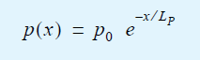
Find the hole-current density at x = 0. Let p0=10¹⁶/cm³. Lp=1um. [15]

